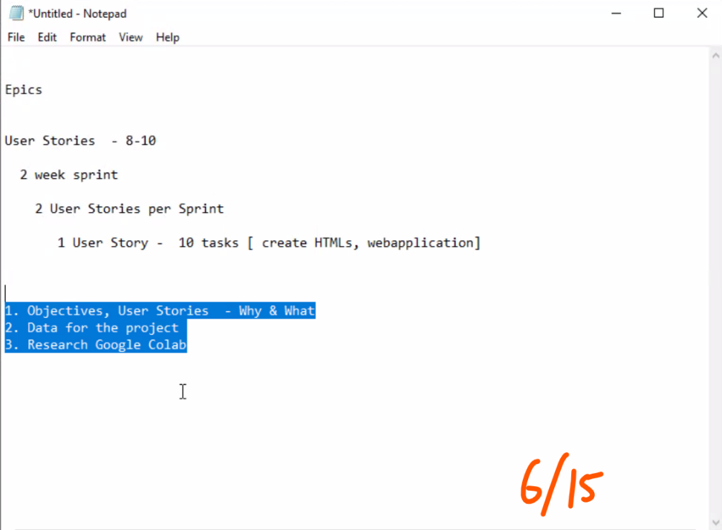

Objective:

1.       Identify usage patterns of apps

2.       Arrange the apps based on the usage patterns

      1 HTML Page  - 10 – 15 Cards

        card 1 – webex  - productivity

        card 12 – AppName 1  - news,

        card 14 – AppName 2  - news,

1.       As a business professional, I want to have my calendar information presented on the screen so that I can have a brief overview of the schedule for the day.

a.       Connect to one’s phone calendar app and obtain data

b.       Develop a model based on importance of meetings to produce brief summary

c.       Create HTML pages and application to display information

2.       As a college student, I want to have delivery notifications with delivery locations presented on the screen so that I can improve efficiency of pickup.

a.       Connecting to the user’s construction materials orders application to obtain data and important contract information

b.       Interface with the GPS to create an optimal pickup path

c.       Create HTML pages and application to display contract information and automated GPS navigation to the pickup location

1.       Decompose the biz prof. & college student user story

2.       Search for app usage data on the internet

3.       Identify 20 apps each for both persona

4.       HTML5 page with 20 cards